YEAR 12 Essentials Mathematics
Semester 1 2017
Test 2 - Volume, Capacity, 2D & 3D shapes, Scale, plans.

.

Total Marks: 45 marks
Name: ______________________ Total Time: 50 minutes


Full working out must be shown to get full marks.

Attempt all questions

Total Time: 60 minutes

Resources allowed:

1 A4 page, (1 side) of hand written notes,ruler

Calculator

- Find the Volume for each figure… [2, 2, 2, 2, 2-10 Marks]

- Volume = _______

7cm

21 cm

- Volume =_______
9m

6m

18 m

- Volume =_______

22m 33m

44 m

- Volume =_______

12cm 14cm

11cm

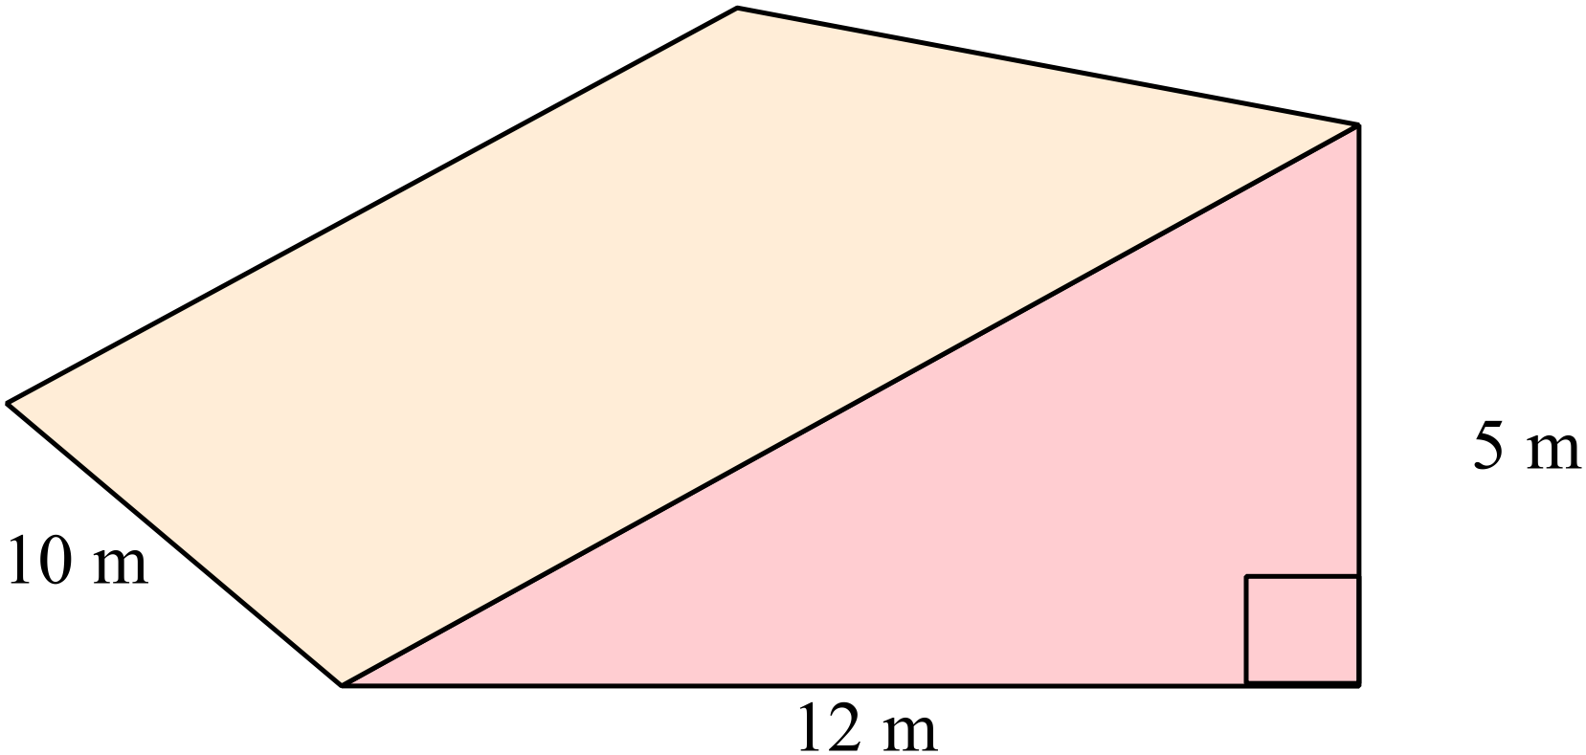
e) Volume =_______

- Convert the following measurement to the units specified: [1,1,1,1 - 4 marks]

a) 7500 cm³ = m³ b) 0.185 m³ = cm³

c) 9 787 200 mm³ = m³ d) 5 m³ = mm³

- Match the nets with the following shapes: [1,1,1,1 - 4 marks]
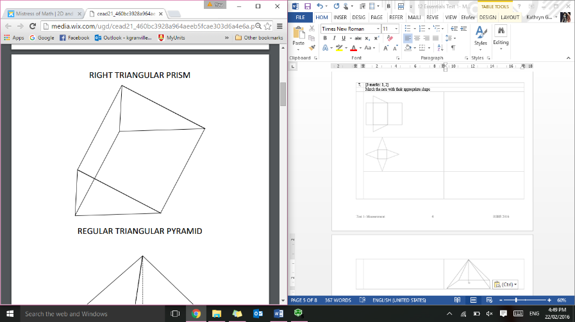
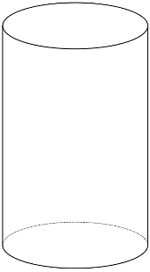
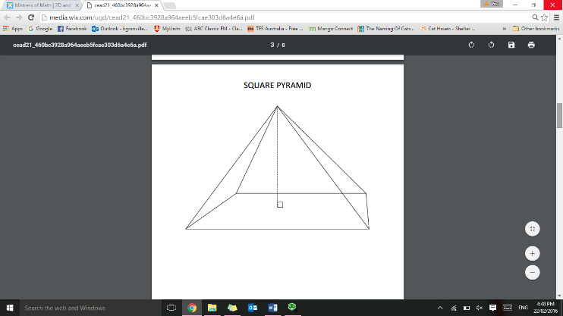
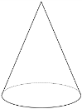

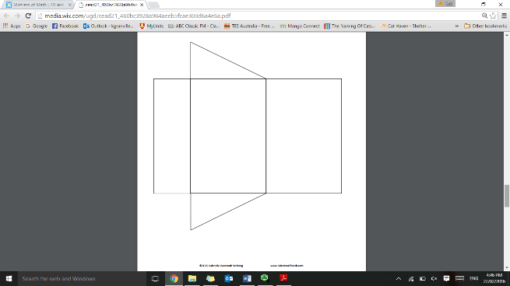
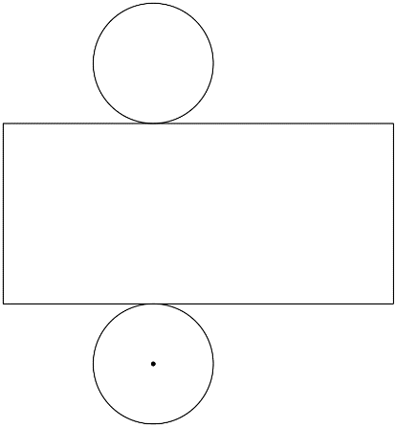
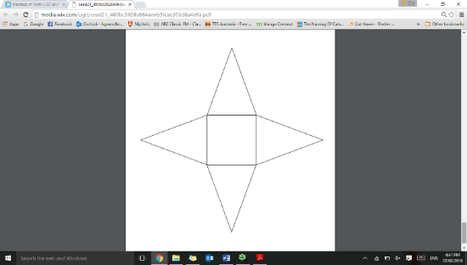
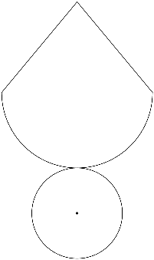

- Thelma and David built a recycling bin that is 6 meters wide, 12 meters long, and 14 meters high. How much trash can fit inside of the bin? [3 Marks]

- The cylindrical canister of a fire extinguisher has a radius of 4 cm and is 12 cm high. How many cubic cm can it hold? [3 Marks]

- Sketch the following: [2, 2-4 marks]

- A regular octagon b) An irregular hexagon

- Cindy went to Maggie Moo’s for an ice cream cone after school. The ice cream cone had a radius of 1 cm, a height of 2 ½ cm, and a slant length of 3 ½ cm, how much ice cream could the cone hold? [3 Marks]

- Adam is building a rectangular planter without a top. The planter will be 7 cm wide, 16 cm long, and 10 cm high. How much wood is needed to make the bottom and sides of the planter? [3 Marks]

- Write the following scales as a ratio in its simplest form, without the units.
[1,1,1,1 - 4 marks]

- 1 cm represents 5 cm

c) 1 cm : 350mm

- 2cm : 20m

d) 0.5 cm : 150 cm

- Below is the floor plan for Miss Granville’s new holiday house. [2, 2, 2,- 6 marks]

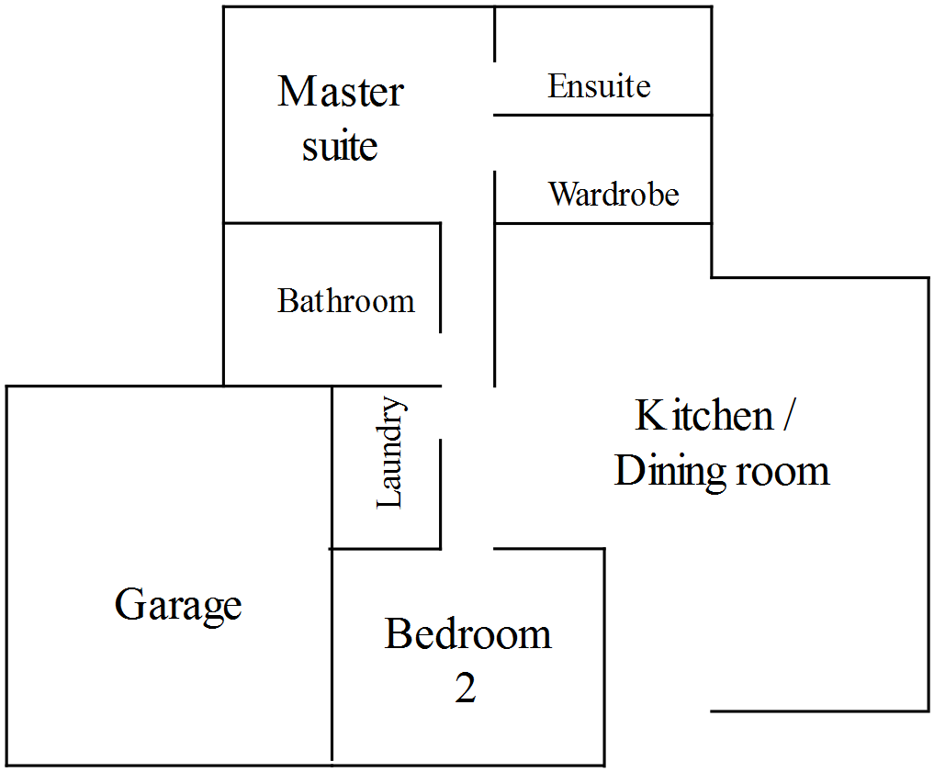

Scale 1:200

  - Using the scale given, find the area of the garage

  - Miss Granville decides that she wants to concrete the floor of the garage. If concrete costs $21.20 per square metre, how much will it cost to complete?

  - The bathroom, laundry and ensuite are to be tiled, with tiles costing $41.40/m². How much will it cost to buy tiles?

End of Test

